PHENOMENON
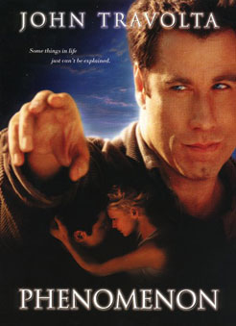
USA, 1996, d. Jon Turteltaub



George Malley is genial and popular, lives in a small town where he experiments with growing vegetables. He also fixes cars. After his birthday celebration, he sees a bright light in the sky which falls towards him and explodes. When he comes to, he is transformed, is highly intelligent and has telekinetic powers. As he discovers more of what has happened to him, he reads, discusses, learns Portuguese in no time to translate for the doctor to help with a patient.

A scientist interviews him and he is apprehended by the FBI who are suspicious about his knowledge and contacts. Meanwhile his puzzled friends support him as does Lace, a furniture maker with two small children, whom he courts.

Eventually, his condition deteriorates and the FBI keep him under custody in a hospital. However, he escapes and goes back to Lace where he dies. She mourns him. But a year later, all the town and his friends gather to celebrate his birthday as his memory and spirit live on.

Phenomenon is one of those films that can really be called nice - which usually means that they appeal to a wide audience, have laughs and tears and leave people feeling good. Jon Turteltaub also directed the `nice' Cool Runnings and While You Were Sleeping, Instinct and Disney's The Kid. It would not be surprising to hear that the screenwriter had been reading the Gospels while writing this film.

It is a feature of many films that `secular' filmmakers are intrigued by the figure of Jesus, his actions, his message and, especially the impact of his death and of his resurrection - and that his spirit still lives.

John Travolta's character, George Malley, is an ordinary man who has a transforming experience that sharpens his mind and enhances his already kind personality. The Gospel parallels emerge as do George's gifts: people wonder at his powers, discuss him among themselves, authorities are suspicious, people ask him for healing. Phenomenon is about the goodness of human nature and the final scene, while not exactly Babette's Feast, has the same message. (Because of John Travolta's being a Scientologist, some have seen a subtext on this Church.)

