GANDHI
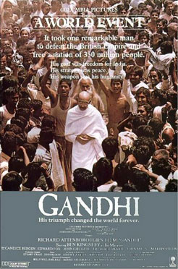
UK, 1982, d. Richard Attenborough



Producer-director, Richard Attenborough planned his epic on the life and death of Mahatma Gandhi for twenty years, eventually releasing it in 1982 where it went on to win Oscar for Best Film as well as Oscars for Attenborough himself as director and for the star, Ben Kingsley. Attenborough already had a long career as an actor and had begun to direct, frequently on a large scale with films like Young Winston and A Bridge too far. He went on to direct, amongst others, Cry Freedom, A Chorus Line and Shadowlands. Ben Kingsley went on to a long and successful career as a star and character actor.

The screenplay by John Briley (Cry Freedom, Molokai) encompasses Gandhi’s adult life, filling in the background of South Africa, Gandhi’s time in England but, focussing on his campaigns against the British in India in the 1930s and 1940s and his assassination. This was the subject of a Hollywood drama in the 1960s, Nine Hours to Rama. Many films from India since the 1980s have tackled the subject of the partition between India and Pakistan and the forced repatriation of Hindus from Pakistan and Muslims from India. It is a tribute to Gandhi and his colleagues that, despite antagonism, both political and religious and the fear of war as India and Pakistan became nuclear powers, both nations have held their disparate people together and that India has survived more than half a century as one of the largest united nations on earth.

The sweep of the movie is one of grandeur, in its visualising of India and its people, in its beauty of landscapes, in its portrayal of heroism and the nobility of the human spirit. The running time is long. The movie is filled with prestigious British stars like Laurence Olivier and John Gielgud. It is a fine example of serious themes being enhanced by ambitious moviemaking.

