FEARLESS
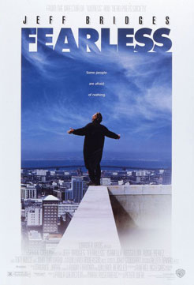
US, 1994, D. Peter Weir



Max Klein emerges from an air crash as a hero, leading people to
safety from the wreckage and carrying a baby. He feels numb but
elated and begins to review his life. Back home, he feels a
distance from his wife and son, annoyed by a psychiatrist and
clashing with a smart, money-chasing lawyer.

Asked by the psychiatrist to talk to a young mother whose two year
old died and who is still in shock, he befriends her. He goes to a
church with her, discusses God's will and is overwhelmed by a
profound love for her. This further puzzles his wife. He secludes
himself in his study and draws and collects paintings of near
death experiences.

He dreams of the crash and remembers seeing a light and losing all fear, going to sit with a boy during the crash. At the same time, he is exasperated by the lawyer and the wheeler-dealings to get money for his partner's family.

Max goes shopping for gifts for the woman's dead son and his dead father and demonstrates to the woman it was not her fault for loosening her grip on her child by crashing his car into a wall. He asks his wife to save him. He almost dies but she revives him once again into a new life.

The screenplay for Fearless is by Rafael Yglesias from his novel. The direction is Peter Weir whose films include Picnic at Hanging Rock, Gallipoli, The Year of Living Dangerously, Witness, Dead Poets Society and The Truman Show. It is also a fine star vehicle for Jeff Bridges as Max Klein, the survivor of an air crash, dubbed a hero and 'The Good Samaritan' but who finds it hard to combine the sense of wonder he experiences in being alive with the ordinariness of his work and marriage.

This is not a mainstream Hollywood entertainment. It tries to imagine and explore some of the realities of suffering, pain and death in the contemporary world, issues of religious faith and the absence of a sense of God while puzzling over the arbitrariness of accidents and wondering about God' role in them. Jeff Bridges is persuasive as the ordinary hero who is motivated to save people. Rosie Perez received an Oscar nomination for her role as the distraught mother who gradually comes to a sense of peace through Max. Isabella Rossellini is the bewildered wife while John Turturro and Tom Hulce are effective as the psychiatrist and the lawyer.

Unusual themes and treatment for an American movie.

