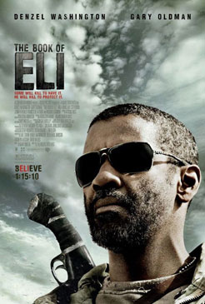
THE BOOK OF ELI

US, 2009, The Hughes Brothers



Welcome, once again, to the end of civilisation as we know it and introducing the wasteland of post-apocalyptic America. Recently, this has been done with tongue in cheek humour in Zombieland and with earnest seriousness in the fine adaptation of Cormac McCarthy's novel, The Road, by John Hillcoat.

Eli has been wandering the devastated United States for thirty years. He is a survivor who is quick, very quick, with arrows, guns and a blade that would make some Samurai envious. Speaking of Samurai, he is the latest in the tradition of Mad Max heroes, a sign of contradiction, violent weapons master but straightforward sage who can be courteous and wise. Since he is played by Denzel Washington the latter almost goes without saying, so it is a surprise to see Denzel wielding the weapons.

The itinerary is familiar enough though the look of it, all desaturated colour and painter-like framing of scenes and of iconic buildings and roads, is quite distinctive and arresting. As is the soundtrack.

Eli shoots a wildcat for meat, is ambushed by a flesh-eating bikie gang which is literally dismembered, and rapidly. A gang rapes a wandering woman and Eli refuses to be involved. He chances on a town, ruled over by power-hungry Carnegie (Gary Oldman reminiscent of his Dracula in look and manner) who has search parties out looking for a book which will enhance his power and offer him a way to control people and their minds. We soon realise that it is the Bible – copies of which seem to have been destroyed because of the role of religion in the destructive wars.

Carnegie runs a bar and has a hold over a blind woman, Claudia (Jennifer Beals) and her daughter (Mila Kunis). The daughter is meant to seduce Eli but, instead, helps him. This brings on more disasters, especially for an elderly couple, with US-symbolism names of George and Martha (Michael Gambon and Frances de la Tour), who offer shelter and tea in china crockery.

The final goal, according to Eli, is 'West'. Actually, it is a destroyed San Francisco though, ironically, Alcatraz is intact and is the centre, under the leadership of Malcolm McDowell, where culture could begin again - with the help of the book of Eli and Christian teaching which takes its library place beside the Quran and other sacred texts.

The film is intriguing rather than involving, something like a futuristic western. The character of Eli is especially intriguing for religious audiences. He is a man who has become the bible incarnate even though he cannot always put it into practice.

After making some strong African-American gang films (Menace II Society, Dead Presidents), the Hughes twins, Alan and Albert, made the intriguing Jack the Ripper film, with Johnny Depp, From Hell.

(Post-script: Some secularists have been mightily offended by this promotion of sacred texts and the role of religion which they see as fostering war and devastation and, because Eli begins with the book of Genesis, some commentators have seen this as part of a Creationist plot – now there's a different conspiracy theory, especially since one of the books that has survived, even out in the wasteland is The Da Vinci Code!)

