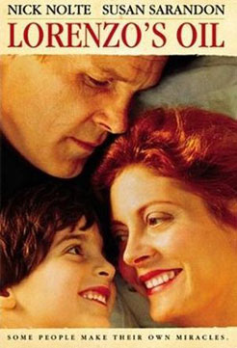
LORENZO'S OIL

US, 1992, d. George Miller



Lorenzo Odone was a young boy suffering from adrenal leukodystrophy, a debilitating disease in brain, blood and limbs. His parents struggled with the medical profession from the mid-80s for support and treatment and learnt to become expert at understanding the disease, even to discovering leads for a remedy, called Lorenzo's Oil.

The Odones were an ordinary couple living in Washington DC who decided that they would fight for the son's recovery no matter what the cost. As Lorenzo's health deteriorated, his mother spent all her time with him, learning more and more about his condition but also finding out that, despite the disease and his difficulties in communicating, her son was maturing intellectually. She changed her reading choices from children's books. She almost willed him to learn how to blink and move his finger to communicate. She was also a formidable antagonist to doctors.

Lorenzo Odone was still living in 2000 but his mother died that year.

Lorenzo's Oil is a fine movie. It is not a so-called disease-of-the-week movie. It is a human drama, a portrait of family, parents and child, as well as a medical case study. The screenplay by Australians Nick Enright and George Miller was Oscar-nominated and is written as a file report on Lorenzo's progress from 1983 to 1992.

Director George Miller (Mad Max movies, Witches of Eastwick, Babe, Pig in the City) is a doctor and has brought his expertise to bear on communicating on screen the complexities of the illness, on the criteria for testing of treatments and the reaction of the medical profession and the drug companies.

The movie is demanding for mind and for emotions, but is a tribute to the human spirit. Susan Sarandon's Oscar-nominated performance is very strong. Nick Nolte, with a realistic Italian accent, gives a solid performance. Peter Ustinov has a serious role as a doctor.

