Marriage & Family Life E-Bulletin
No 26 March/April 2008
Marriage & Family Life Project Office,
Department of Christian Responsibility & Citizenship,
Catholic Bishops’ Conference of England and Wales
Back Issues
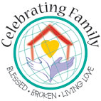
Contents  Home is a Holy Place  Families and Mental Health  Marriage Care News  Interfaith Relationships  A Future for Marriage?  Contact Us  To ensure that you receive  this free e-newsletter or to remove yourself from the mailing list please email elizabeth.davies@cbcew.org.uk  ____________________  Project websites  www.celebratingfamily.org.uk  www.everybodyswelcome.org.uk  www.homeisaholyplace.org.uk  www.passingonthefaith.org.uk  Diocesan dates  May 10th. Diocese of Nottingham Home is a Holy Place event. Mickleover, Derbyshire.  Diocesan Vacancies  The Diocese of Leeds is seeking a part-time Parent Support Worker. Contact Breda Theakston for an application pack.  Project Resources available:  Home is a Holy Place: Resource Pack. Coming soon. Further details  Family – An Adventure in Love An A4 four page glossy leaflet for help communities of faith celebrate their households of faith. Details and order form.  What is Life Like? A set of 7 leaflets to support welcoming families in challenging circumstances. £2 each from the project office or free online.  Check it out  To mark the Pope’s recent visit to the United States, iMAPP (Institute for Marriage and Public Policy) published a Research Brief listing a compendium of comments made by Pope Benedict XVI on marriage. You can view a copy here.  Contacts:  Elizabeth Davies, MFL Project Officer. Tel: 01902 621594 Email: Elizabeth.Davies@cbcew.org.uk  Veronica Murphy, MFL Training & Development Officer.  Tel: 0771 4261883 Email: Veronica.Murphy@cbcew.org.uk  Annabelle Williams, MFL Project Office Administrator Tel: 020 7901 4823 Email: Annabelle.Williams@cbcew.org.uk  Roberta Canning, Volunteer Development Worker (Mental Health Project). Email: Roberta.Canning@cbcew.org.uk  Marriage & Family Life Project Office, 39 Eccleston Square, London SW1V 1BX  Please feel free to reproduce anything in this bulletin and to forward it to anyone you think would be interested. | Home is a Holy Place: Resource Pack  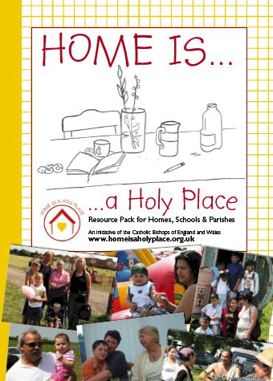  The long awaited Home is a Holy Place Resource Pack has now been published and is in the process of being despatched from Eccleston Square to dioceses who have requested copies. A free pack is available for each parish in England and Wales, distributed within each diocese by the local contact for the Celebrating Family initiatives. This resource has been produced in response to a request for new materials made by participants at the Releasing Formidable Energy symposium held in October 2006. A limited number of copies of the pack are available to buy at a cost of £10 each, which includes a free DVD. Download an order form on the Home is a Holy Place website. Additional material and electronic copies of the contents of the pack will be available there shortly. Contact the Project Office to find out who is distributing packs in your local area.  Families, Mental Health and Pastoral Care in Hallam  Over forty people attended a day conference at St Wilfrid’s Centre, Sheffield on Saturday, April 12th 2008 to explore how parishes can respond to those affected by mental health issues. Organised by Diocese of Hallam Caring Services, the agenda featured a keynote speech by Fr Andy Graydon, Chaplain, Doncaster & South Humber Mental Health Trust. Later in the day a powerful drama called Katie’s Story, performed by ‘Whole In The Head’ gave an insight to the experiences and feelings of someone suffering from mental health problems. Read more… The latest newsletter from the Mental Health Support Project is now available to download here.  New Website for Marriage Care  Marriage Care, the second largest relationship organisation in the UK after Relate, has a new look website which is well worth exploring. “As a marriage support organisation, Marriage Care has a very definite stake in marriage and all adult long-term relationships. We are concerned with the institution of marriage and it's meaning in today's society, as well as the quality of individual committed adult relationships. We help people prepare for, achieve and sustain successful marriages and to support them should these break down.” A guide to getting married in the Catholic Church is available to download from the home page.  Interfaith Relationships: A Resource Pack for Couples  Rosalind Birtwistle and Heather Al-Yousuf of the Interfaith Marriage Network have just published Interfaith Relationships: A Resource Pack for Couples. The booklet aims to help couples in interfaith relationships explore the special issues they face and find out where they can get information and support. Topics covered include the practicalities such as planning a wedding, managing religious food rules at home and the teachings of different faiths about marriage and family life. There are also sections to help couples explore what faith and culture means to them and how to cope with religion at home and in public. The booklet can be downloaded or viewed free of charge on their website.  What Future For Marriage in Postmodern Times?  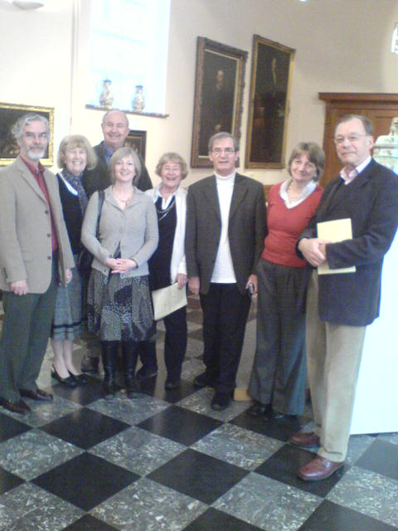  Three diocesan marriage and family life coordinators and their spouses took part in an INTAMS colloquium at the Catholic University of Leuven University on 7-8 March 2008. What Future for Marriage in Postmodern Times? drew academics, students and marriage and family ministers from across Europe to explore persisting and newly emerging meanings of contemporary marriage. Keynote speaker Stephanie Coontz, author of Marriage, a History: How Love Conquered Marriage offered a whirlwind tour of marriage throughout history and diverse anthropologies and cautioned against placing too many burdens on modern marriage as an antidote to social changes. Enda McDonagh, responding to Bernd Wannenwetsch of Oxford University, described the essential challenge of lifelong marriage as always seeking to discover and welcome the stranger in the other. Papers from INTAMS colloquia are always published in the INTAMS Review which is printed twice yearly. The photo shows (l to r): Charles and Clara Donnelly (Shrewsbury), Dr David Thomas (marital theologian), Elizabeth Davies, Anne and Jim Ballard (Cardiff), Liz and Neil James (Arundel & Brighton).  Play: A Need of Families in Our Time?  The Flame network within the Church of England has cancelled its planned conference on play due to take place at Harborne Hall in Birmingham from 20th -21st June 2008. Visit the Flame website for more information.  Please accept our apologies for the late delivery of this monthly newsletter. A range of developments (not least the finishing touches to the Home is a Holy Place Resource Pack) have delayed its production.  NB: The CBCEW website has recently been redesigned. If you have any links to the old site please check whether you need to change them. It’s taking us some time to restore all the information we had available online regarding support for marriage and family life. Our index page is now here.

