Bread for the Eucharist

Two recipes for bread, both fully conforming to the requirements for bread to be used at Mass.

Communities or parishes intending to use freshly baked bread into use at their masses, should ensure that proper catechesis is provided for the whole assembly in advance of the introduction of the new practice.
Those taking responsibility for the baking of bread for mass might first practice with both recipes given here and see which is best suited to their local circumstances.
Unlike the wafers generally used at Mass, freshly baked bread that is consecrated will quickly go stale. Therefore when using freshly baked bread at Mass, thought should be given in advance as to how any of the Body of the Lord remaining after the distribution of communion is to be consumed. Always it must be consumed reverently, and it is usually better for it to be consumed after the assembly has been dismissed and Mass is ended.
Experience will quickly teach the presiding priest how to estimate the numbers at the Breaking of the Bread so as not to be left with an excessive residue. It is normally better to underestimate the number of people present rather then over as it is always possible to further break the individual pieces, should this prove necessary.

Recipe 1
For 70 Communicants
50g Whole wheat flour
100g unbleached Strong White flour
110ml Water: naturally effervescent (Perrier for example), refrigerator cold
1. Sift together 50g whole wheat flour to 100g unbleached Strong White flour. The mixture of flour should be kept in an airtight container in the freezer and used while cold. (The cold flour helps prevent a separate crust from forming.)
3. Quickly mix the flour and water together with a fork until all the flour is moist. Form dough into a smooth ball. Usually more flour needs to be sprinkled on the surface of the dough to prevent stickiness.
4. Gently flatten the ball of dough into a circular loaf about 1 to 1^{1/}₂ cm (1/2 to 3/4 inch) thick. If necessary, turn any uneven edges underneath.
5. Place unscored loaf on a non-stick baking sheet.
6. Place in a preheated oven at 220 degrees (gas mark 7).
7. After approximately 12-15 minutes the top crust should have raised slightly. Prick the crust with a toothpick in several places, turn the loaf over and continue to bake about five minutes. (This gives an evenness to the top of the loaf.)
8. Turn the loaf right side up again and continue to bake until the crust is very lightly browned, about 10-15 minutes more for a total of 25-30 minutes. Baking time when using larger amounts of dough needs to be extended.
9. Place the loaf on a rack for cooling. (You may want to slice the bottom crust off to check for any rawness.)
10. Bread is best when made fresh for the day of the liturgy. However, after baking it can be tightly wrapped and frozen for later use.

Recipe 2
Makes 4 loaves (each loaf will provide for 40–50 people when broken – total between 160-200 people). The recipe meets the Church’s requirements regarding bread for use at Mass.

Ingredients:
400 gm 12 oz whole wheat flour (strong bread flour)
100 gm 4 oz plain (preferably unbleached) white flour
300 ml 10 fl oz warm water (⅓ boiling ⅔ cold
Note: Allow more wheat flour for rolling out the dough.

Estimated Total Preparation Time: about an hour

Tools Needed:
- 1 medium-size mixing bowls
- scales and measuring jug
- butter knife for scoring
- Rolling pin
- sifter
- pastry brush.
- 3 inch or 7 cm. diameter glass / cup / bowl for scoring loaves
- 6 inch or 15 cm. diameter glass / cup / bowl for stamping loaves
- Baking sheet and/or baking parchment: Use of a good quality heavy non-stick baking sheet and/or baking parchment helps the bread to bake more evenly, prevents burns, and obviates the need to ‘oil’ the baking sheet.
- metal spatula

Directions
- Preheat the oven to 180 degrees C (350 degrees F) (adjust for fan ovens). After cleaning the work space, wipe once more with plain hot water. You will be putting flour and raw dough here. Make sure your hands are "impeccably clean." Assemble all the bowls, tools and ingredients needed.
- Sift together the whole wheat flour and white flour into a medium-size mixing bowls.
- Mix with the water with the flour until all has been gathered in—the dough will be somewhat stiff
- If you can’t seem to gather in all the flour after about 30 seconds of mixing, measure add a little more warm water, a tablespoon at a time, to the mixture. It should be quite dry – try not to over-wet it.
- Sprinkle the work service with wheat flour to keep the dough from sticking to it. As the dough should be somewhat stiff, you probably won’t need much extra wheat flour to facilitate the kneading.
- Place dough on the work service and kneed for about 5 – 6 minutes. The kneading is important to prevent puffing or ballooning during baking.
- When the dough is smooth and pliable, form the dough into a ball, cover it with a dampened clean cloth and let it rest for about 5 minutes. The cloth will prevent a crust from forming.
- Break the large ball of dough into 4 smaller balls of equal size.
- Roll out each ball into a 6 inch (15 cm) wide round about a 1/4 inch (1/2 cm) thick. Stamp it out with the larger bowl and then score the centre as in the instructions for scoring. Carefully transfer each loaf from the work service to the baking sheet.
- Bake at 180 degrees C (350 degrees F) for 16 – 17 minutes. Can take up to 3 – 5 mins longer.
- Transfer the rounds to racks for cooling.

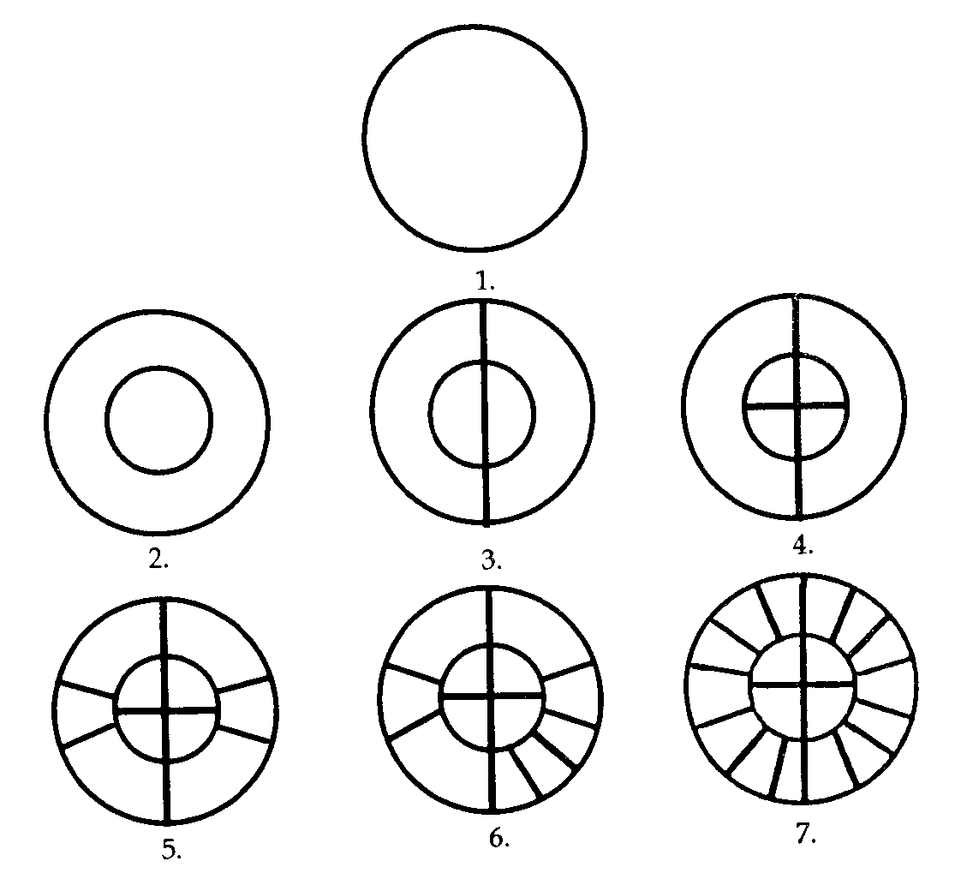
Directions for scoring

- Stamp out a 6 inch (15 cm.) round using suitably sized bowl. Peel away the excess dough (scrap) and put it aside.
- Deeply imprint with a 3 inch (7 cm.) circle — make sure it is centred.
- With a butter knife or the dull side of a regular knife, score a vertical line through the centre—deeply.
- Score a horizontal line only across the inner circle—deeply.
- Score the two side pieces—deeply.
- Score deeply each remaining large corner section into three equal pieces.
- Stamping and scoring completed.
- Each segment should be broken in 2 pieces – some will easily break into 3.
Storing
Maximum Storage Times
- up to 4 hours, unwrapped and unrefrigerated
- up to 24 hours, wrapped but unrefrigerated
- up to 6 days, thoroughly wrapped and refrigerated
- up to 40 days, thoroughly wrapped and frozen
Wrap each loaf, after it cools, in a separate piece of microwave safe cling film. Place all loaves in a plastic container.
Defrosting: unwrap what is needed and then heat not more than three loaves at a time in the microwave for 1 or 2 minutes per loaf. When done, each loaf is piping hot, as if just baked. Air-thawing and oven-thawing don’t seem to work nearly as well.
Notes:
If you get fewer than four 6 inch (15 cm.) rounds, you're probably rolling them too thick. If you get more you're probably rolling them too thin.

If you need to make more than 4 loaves (rounds), you can double the recipe, although you will have to increase the baking time to compensate. Tripling the recipe is not recommended — make as separate batches.

