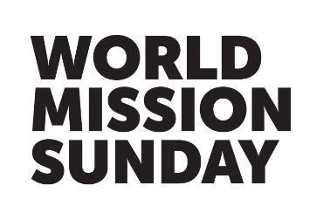

Practical FAQs

Why are all parishes throughout the world asked to support World Mission Sunday?
World Mission Sunday is our chance to show love and solidarity to our brothers and sisters overseas. In offering our prayers, we join with missionaries everywhere in communion and compassion to support them in spreading the Good News, and by giving a donation we respond to Christ’s call to share our faith in Jesus so that all may experience God’s love.

The funds raised build much-needed infrastructure, from chapels and schools to orphanages, clinics and dispensaries. World Mission Sunday is one of only three Papal collections and has been especially chosen by the Holy Father to support the mission of the Church in the world via Missio.

Where do I send the World Mission Sunday collection?
Please send donations from your parish directly to Missio in the Freepost envelope provided. Cheques from parishioners, made out to World Mission Sunday or Missio, can be sent directly to us together with the parish collection and any completed Gift Aid forms and Donation envelopes.

Please do not send to your diocesan offices. If parishioners wish to complete the form on our prepaid Donation envelopes to give by card, please remind them to return these directly to Missio, rather than place them in the parish collection. They will be added to your parish total.

How can people donate online?
Individual supporters can give directly through our secure website. Simply visit missio.org.uk/wmsdonate to help build a future of hope around the world.

