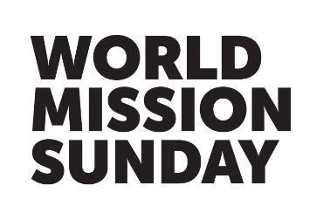

Inserts for your Parish newsletter
‘Go and invite everyone to the banquet!’ cf. Matthew 22:9

Sunday 13 October – Next Sunday is World Mission Sunday
Next Sunday, the Holy Father invites all Catholics to support Missio, his charity for world mission, through a special collection. This day of prayer, solidarity, and giving unites Catholics worldwide to share the Good News of God’s love which has the power to transform lives and heal our world. To donate, use the Missio envelopes, call 020 7821 9755 (office hours) or visit missio.org.uk to give a gift, set up a Direct Debit, and Gift Aid your donation if possible.

Sunday 20 October – Today is World Mission Sunday
Today, parishes worldwide celebrate World Mission Sunday. By supporting Missio, the Pope’s charity for world mission, we stand united as God’s global family, in prayer, solidarity, and action. We are called to ‘go and invite everyone to the banquet’ for the joy of Christ’s Resurrection is a gift meant to be shared with the entire world. Please pray for missionaries and give what you can to this vital collection, bringing God’s compassion, peace, and justice to those in need. To donate, use the Missio envelope, call 020 7821 9755 (office hours) or visit missio.org.uk to give a gift, set up a Direct Debit, and Gift Aid your donation if possible.

Sunday 27 October – Thank you for celebrating World Mission Sunday
Thank you for your donations to the World Mission Sunday appeal. Your prayers and support will help missionaries work alongside communities worldwide, regardless of background or belief. Please continue to pray for all who share the love and hope of Christ with our sisters and brothers in need throughout the world. To support mission year-round, visit missio.org.uk or call 020 7821 9755 (office hours).

