PRAISE TO YOU ETERNAL WORD
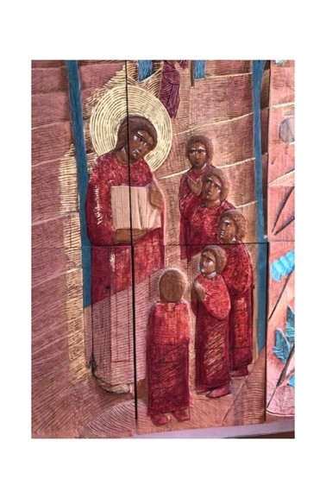
This hymn may be sung to any tune with metre 8.7.8.7.8.7 e.g. Praise my soul the King of Heaven

By your Word Almighty Father
All creation came to be
Beauty of the earth and heavens
Called forth from eternity
Word of life from the beginning
One with God in majesty
In the scriptures we behold you
As the God who speaks in love
By your Son you then spoke to us
Gift of grace from realms above
Radiant light of your great glory
Word who shows the Father's love
Saving Word you dwelt among us
Took on flesh and bore our pain
Shared in all our joys and sorrows
Died for us and rose again
Now ascended to the Father
Glorious Word with mercy reigns
Grant us Lord the grace to listen
Help us trust and live your Word
May it be a lamp to guide us
As we follow you O Lord
Praise to you Almighty Father
Spirit and Eternal Word
Acknowledgements: Words © Alex Heath 2019
Image of Christ and the Word, Northampton Cathedral, Stephen Foster

