How to apply

Prices, per person including full board and lodging:
£320 for single room with shared facilities; £360 for single room en-suite; £290 each sharing twin/double en-suite. There is a reduced price available for those of limited means. Please contact us for details.

To secure a place, you will need to send a deposit of £50 (cheques payable to ‘Boarbank Hall’). The balance will be payable on arrival.

For further information or to book please contact
Sr Margaret Atkins:

margaret@boarbankhall.org.uk

Tel: 015395-32288

Boarbank Hall,
Grange-over-Sands,
CUMBRIA LA11 7NH

.

What are we about?

Doctors and nurses are dealing every day with matters of life and death. Yet they are usually so busy, and so overwhelmed by targets and paperwork, that they have no time to reflect in peace on how and why they do their work, or how it relates to their own spiritual lives and to those of their patients.

Our week aims to provide a restful, restorative and encouraging space in which you will be able to do just that.

The week will include talks and discussion, the opportunity for shared prayer, time for leisure activities, and plenty of space to relax, think and chat in beautiful and peaceful surroundings.

It is aimed at doctors, nurses, chaplains and allied health professionals, who are
Christians of any persuasion.

For more information
and pictures see
www.boarbankhall.org.uk

.

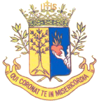
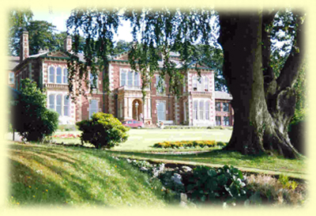

Health and Salvation
Faith and Mental Health

A retreat and holiday for healthcare professionals
Boarbank Hall, Cumbria

12th-17th January 2015

What will happen?

Talks and discussions
*Mental health and human nature
*What counts as mental health?
*Confession or counselling?
*The Bishops’ dementia project
*Questions of training
*Methods in research
*Mind and spirit in the NT

Prayer
You will be invited to join in:
* Daily Mass
* Morning, Evening,
and Night Prayer

You will be free to use the chapel, oratory and gardens for private prayer and quiet reflection

Other activities
*Tour of the Nursing Home
*Film evening
*Day out in the Lake District
*Social evening
*Local walking and sight-seeing
Where will it be?

Boarbank Hall is situated near Grange-over-Sands in southern Cumbria, on the edge of the Lake District, with a fine view over Morecambe Bay.

Since 1921 it has housed an Augustinian convent. The sisters share a common life based on the Rule of St Augustine, with a focus on hospitality, and on care for the poor and sick.

The group will occupy the convent’s very comfortable guest house, with full access to the attractive gardens, which include a tennis court. The convent’s spacious chapel will be available for the use of the group. We will also share in some of the community's prayer.

There are railway stations at
Cark & Cartmel and Grange-over-Sands with direct links to Manchester and Preston.

Who will speak?

Speakers will include:
Bishop Richard Moth, who is responsible for the Catholic Bishops’ Mental Health project (http://www.mentalhealthproject.co.uk).

Dr Siobhan Reilly, Senior Lecturer in Health Research at Lancaster University. Dr Reilly’s interests include the coordination of healthcare provision, and methods of training and assessing research for both acute mental health and dementia.

Sr Margaret Atkins and Fr Richard Taylor, who are resident at Boarbank Hall, will provide theological reflections on the topics of the week.

Our chaplain for the week is Fr David Egan, a priest of the Salford Diocese and a highly experienced hospital chaplain. He and Fr Peter Rosser, currently chaplain to both a Carmel and a prison, will lead a discussion on confession and counselling.

The programme is still to be finalised.

